**Name:- Piyush Sunil Patil**

**Roll No:- 143**

**Practical No:-4**

**Practical Name:-Use git push to send your change to the primary repository. Look online to see if your change has been pushed.**

Dhiraj@DESKTOP-K44LLJ3 MINGW64 ~

$ git clone https://github.com/Dhirajpatil129/MCA.git

Cloning into 'MCA'...

remote: Enumerating objects: 3, done.

remote: Counting objects: 100% (3/3), done.

remote: Total 3 (delta 0), reused 0 (delta 0), pack-reused 0

Receiving objects: 100% (3/3), done.

Dhiraj@DESKTOP-K44LLJ3 MINGW64 ~

$ cd MCA

Dhiraj@DESKTOP-K44LLJ3 MINGW64 ~/MCA (main)

$ git init MCA

Initialized empty Git repository in C:/Users/Dhiraj/MCA/MCA/.git/

Dhiraj@DESKTOP-K44LLJ3 MINGW64 ~/MCA (main)

$ touch MCA1.txt

Dhiraj@DESKTOP-K44LLJ3 MINGW64 ~/MCA (main)

$ git status

On branch main

Your branch is up to date with 'origin/main'.

Untracked files:

(use "git add <file>..." to include in what will be committed)

MCA/

MCA1.txt

nothing added to commit but untracked files present (use "git add" to track)

Dhiraj@DESKTOP-K44LLJ3 MINGW64 ~/MCA (main)

$ git add MCA1.txt

Dhiraj@DESKTOP-K44LLJ3 MINGW64 ~/MCA (main)

$ git commit -m "First commit"

[main 8865e63] First commit

1 file changed, 0 insertions(+), 0 deletions(-)

create mode 100644 MCA1.txt

Dhiraj@DESKTOP-K44LLJ3 MINGW64 ~/MCA (main)

$ git push -u origin main

Enumerating objects: 4, done.

Counting objects: 100% (4/4), done.

Delta compression using up to 8 threads

Compressing objects: 100% (2/2), done.

Writing objects: 100% (3/3), 277 bytes | 277.00 KiB/s, done.

Total 3 (delta 0), reused 0 (delta 0), pack-reused 0

To https://github.com/Dhirajpatil129/MCA.git

fae9510..8865e63 main -> main

branch 'main' set up to track 'origin/main'.

Dhiraj@DESKTOP-K44LLJ3 MINGW64 ~/MCA (main)

$

**Create repository:-**

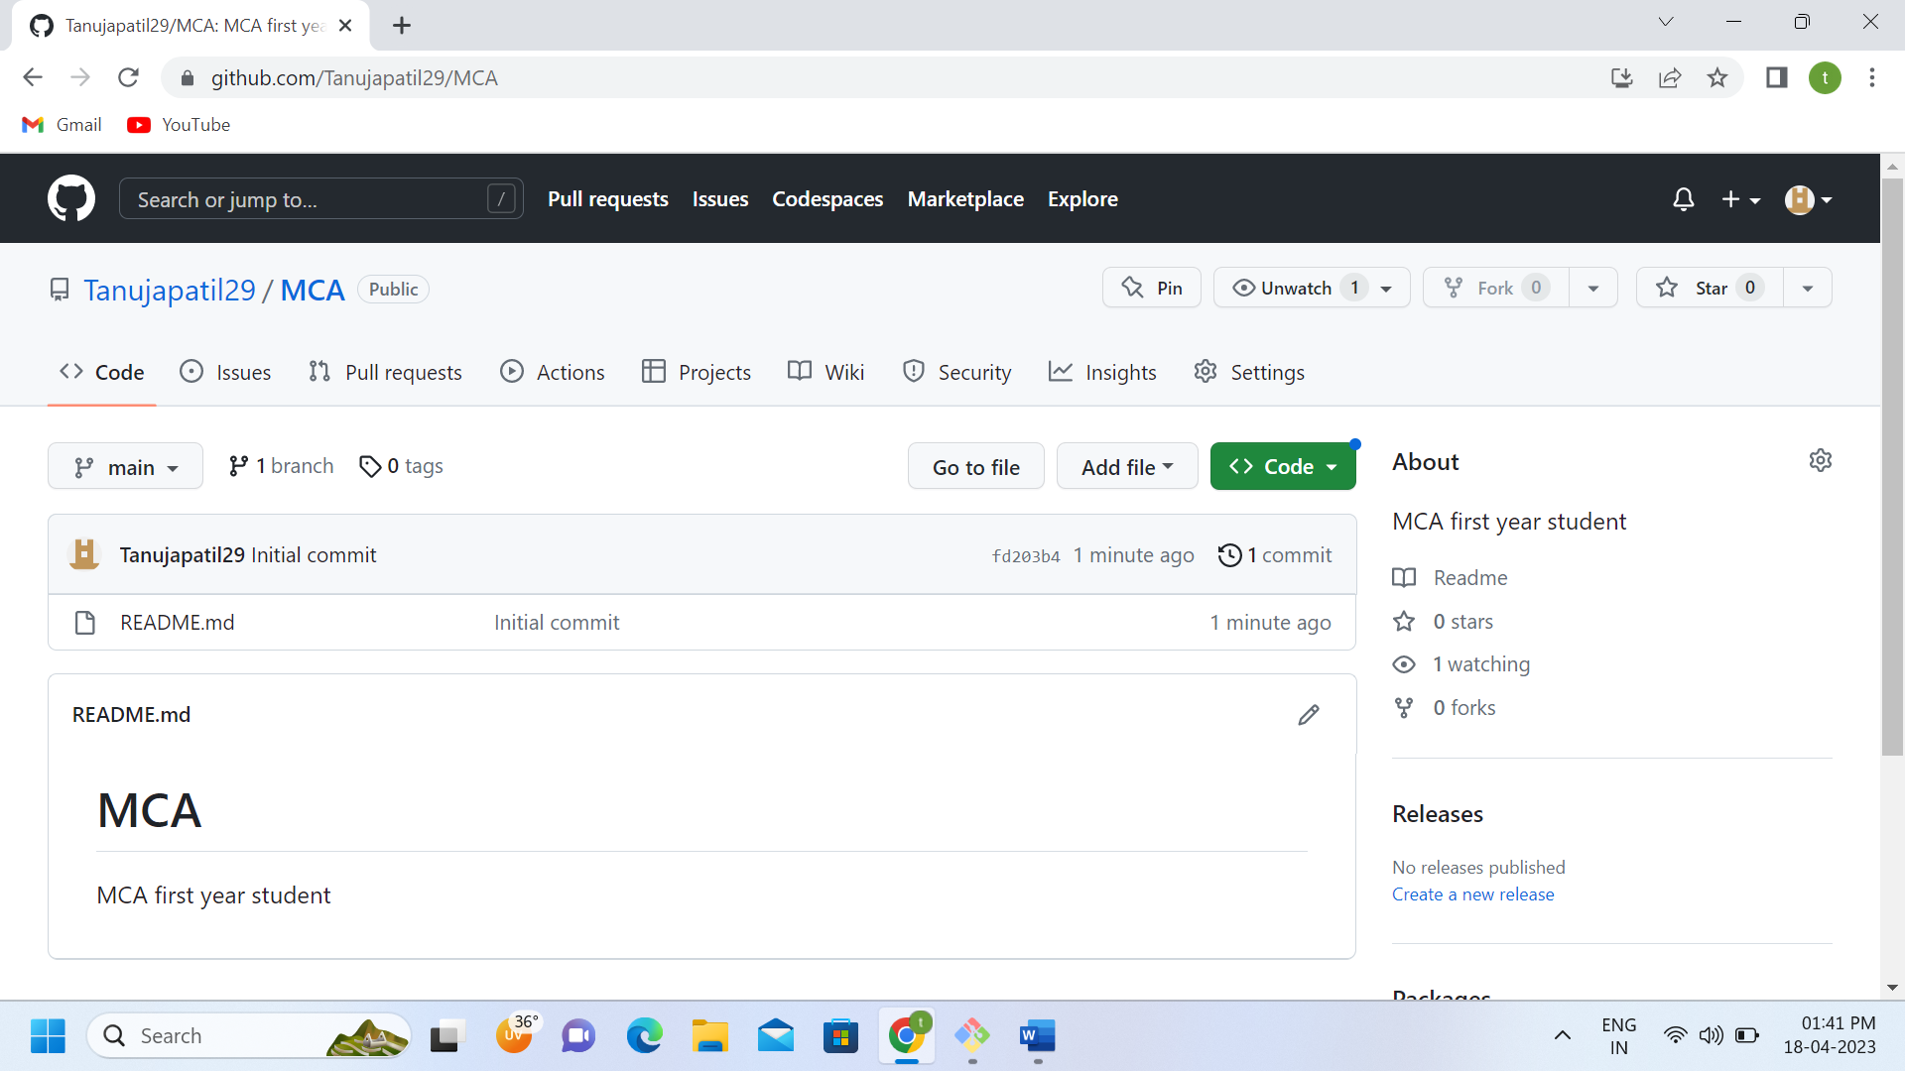

**Before push:-**

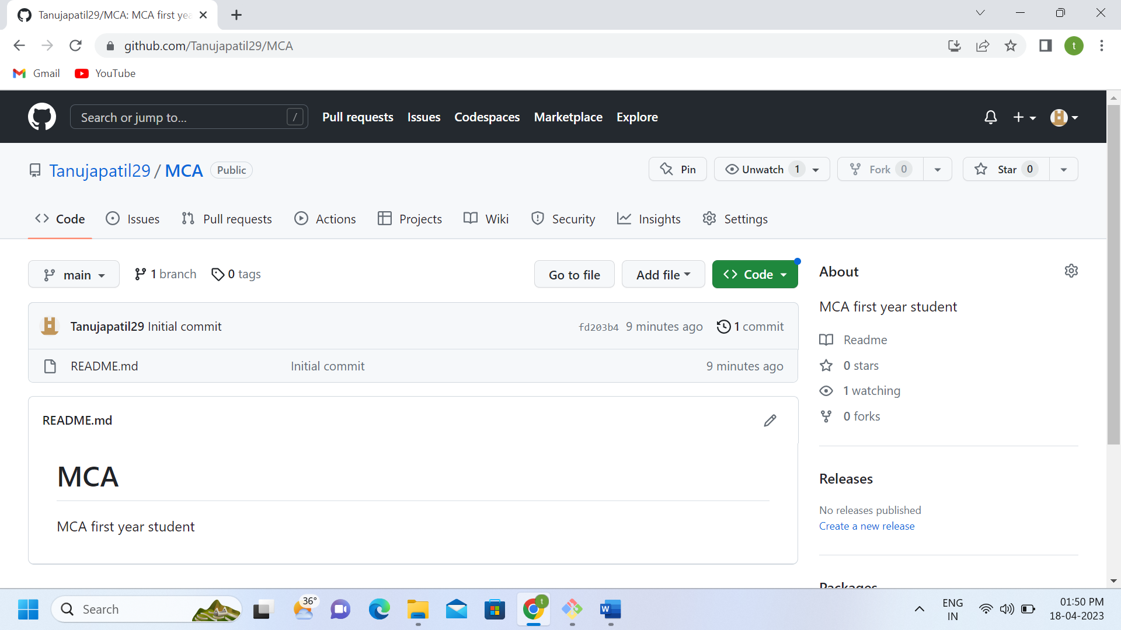

**Authentication :-**

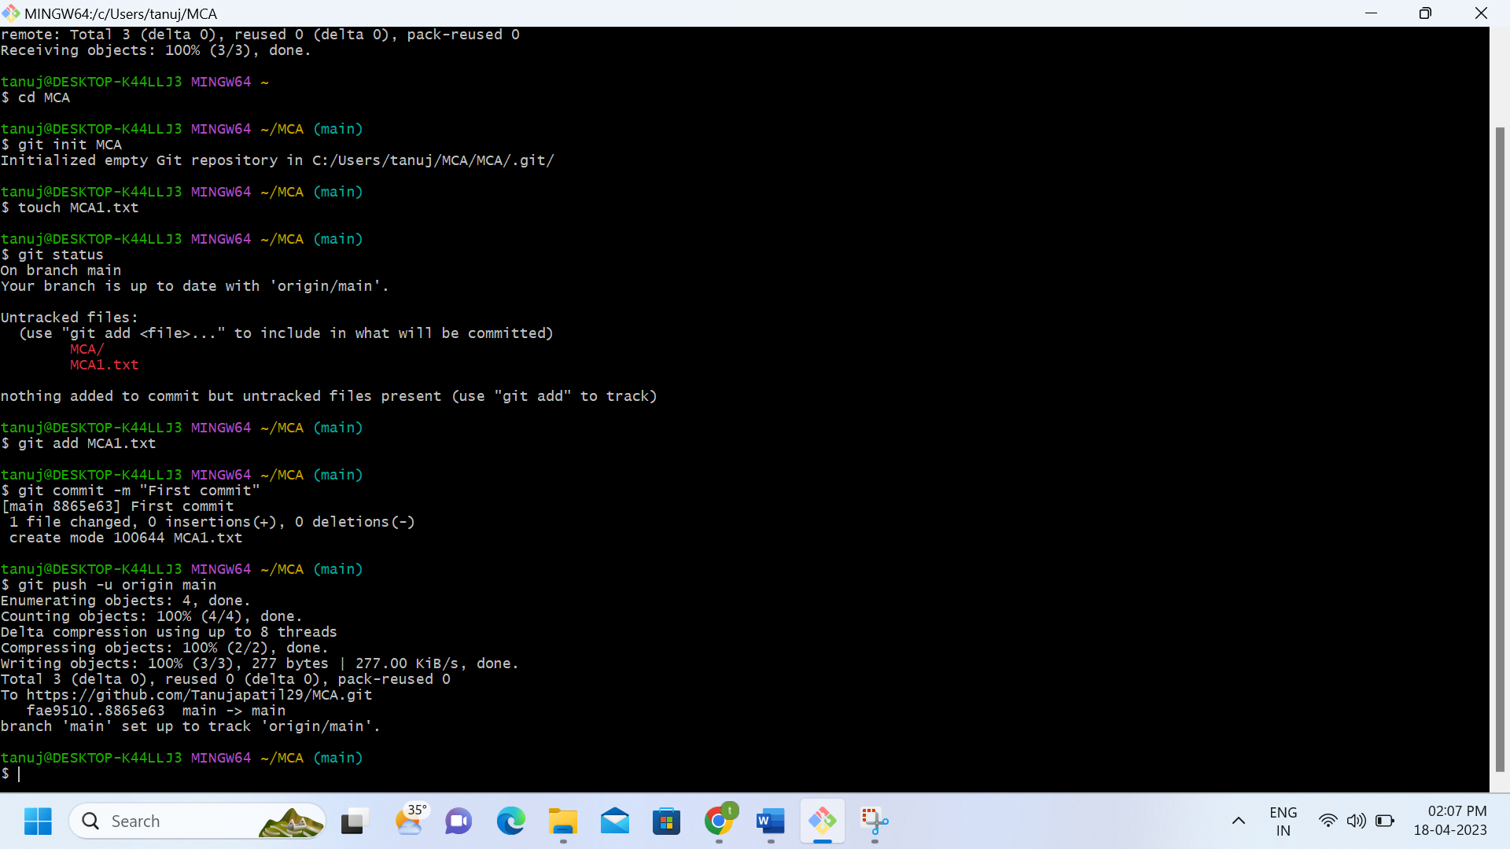

**After push:-**

